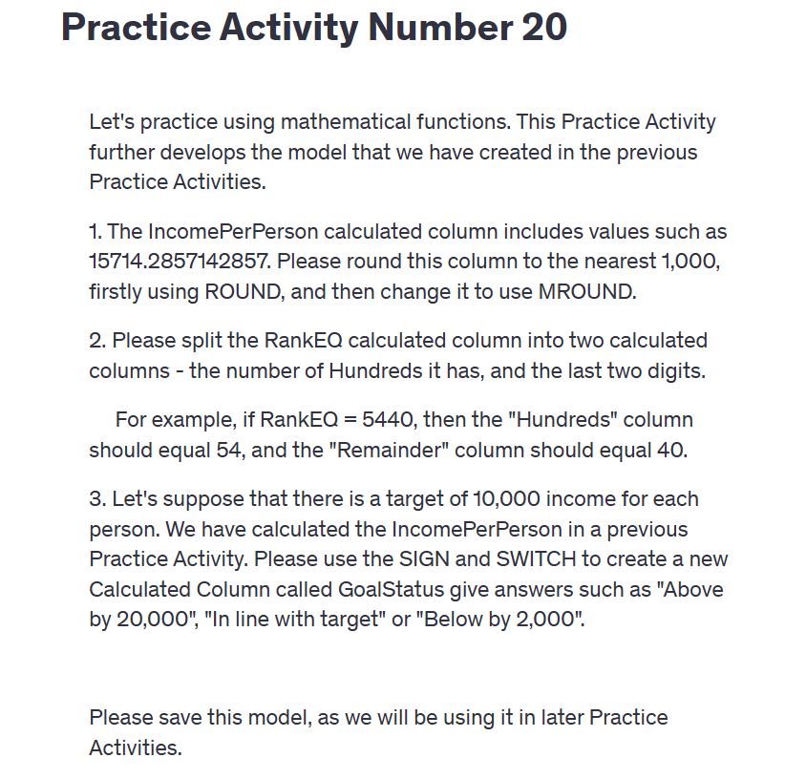  
  
Practice Activity Number 20

Let's practice using mathematical functions. This Practice Activity further develops the model that we have created in the previous Practice Activities.

1. The IncomePerPerson calculated column includes values such as 15714.2857142857. Please round this column to the nearest 1,000, firstly using ROUND, and then change it to use MROUND.

2. Please split the RankEQ calculated column into two calculated columns - the number of Hundreds it has, and the last two digits.

For example, if RankEQ = 5440, then the "Hundreds" column should equal 54, and the "Remainder" column should equal 40.

3. Let's suppose that there is a target of 10,000 income for each person. We have calculated the IncomePerPerson in a previous Practice Activity. Please use the SIGN and SWITCH to create a new Calculated Column called GoalStatus give answers such as "Above by 20,000", "In line with target" or "Below by 2,000".

Please save this model, as we will be using it in later Practice Activities.